25.73: a) The line voltage, current to be drawn, and wire diameter are what must be considered in household wiring.
b) 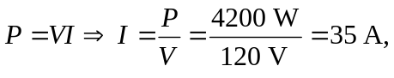 so the 8-gauge wire is necessary, since it can carry up to 40 A.
c) 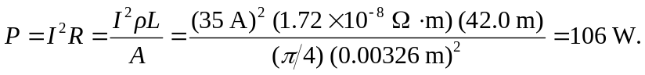
d) If 6-gauge wire is used,
